Mathacademy

**Statement of Goals**

My web application, Mathacademy, is going to be something that will provide math help for kids, grades kindergarten to 8. I suppose it could also be used by parents and teachers, to help their kids or students learn. The main idea of the project will be that there are different concepts for each grade, there is an example and explanation for each concept, and then after you can test your knowledge with a quiz. You will “finish” that concept when you get 100% on the quiz, which you can retry multiple times.

**Functional Description**

When you first go to the website, you encounter the home page. This will have an option to either sign-up or sign-in. The first time, the user will be required to sign-up. Clicking on the sign-up button will take you to a page, where you will be required to enter your email and make a password. Once you make an account, you will be taken to a page which then asks you to pick your grade, from kindergarten to grade 8. Once you choose your grade, the page will show you all the concepts for that grade. You can then choose a concept and start learning. Each concept, regardless of the grade, will have an explanation page with an example, and then once you are comfortable, you can do the quiz that will have questions about that concept. That is for the first time you log in. All the other times you sign-in, which you can do by clicking on the sign-in button on the home page, it will take you to a different page. This page shows you what lessons you have recently finished or are in the process in doing, and when you click on them, it takes you to those lessons. The page also gives you the option of choosing to learn a new concept, by taking you to the concept page of the grade you previously chose. If you want to choose another grade, you can also do so on the homepage. When you sign-in, you can also view your progress tracker. The progress tracker will show you which concepts you have completed, and which ones you are still in the middle of. To be “finished” a concept, you have to get 100% on the quiz, and if you only have 50% on one quiz, the progress tracker will tell you that you are only 50% finished the concept. You have the option of redoing the quizzes as many times as possible, so that you can get 100% on all the quizzes.

**User Interface**

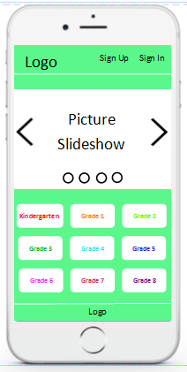  
This is the home screen for my web application. It will have my logo on the top left, with links to the sign up and sign in pages. The picture slideshow will have pictures of something math related, what exactly it will feature hasn’t been determined yet. The grades buttons take you to the lessons/concepts page for that grade.

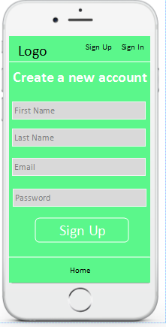

This is where the sign up button on the home page takes you. It will allow you to create an account, and to do so you have to enter your name, email and create a password.

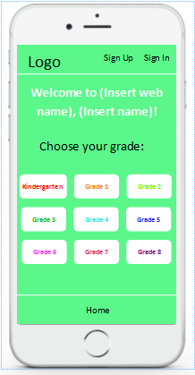

This is where you are taken once you have created an account on the page above. It asks you to choose your grade, so that it can take you to the right page.

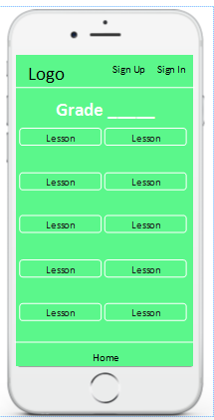

This will be the next page you are taken to after you have chosen your grade. It will be all the different math lessons/concepts for each grade.

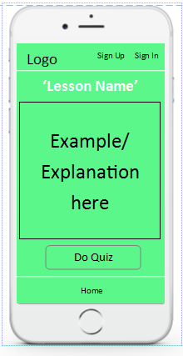

This will be what each concept, which you would have picked from the page above, would look like. In the box, there would be an explanation along with an example, teaching what the concept is. The “Do Quiz”, button will take you to the relating quiz for that concept.

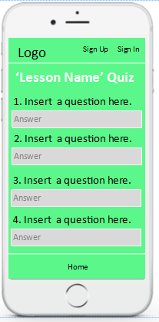

This is what the “Do Quiz” button, from the page above, would take you to. This would be a quiz for whatever concept you just learned about, and it would have questions, and you would input the answer, and it would give you a mark based on how many answers you got right or wrong.

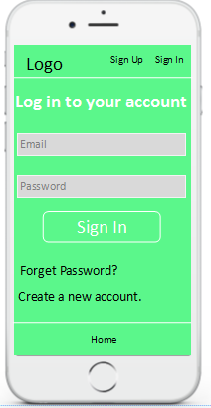

This is where you would sign in to your account, every time after the first time, where you put in your email and the password you created.

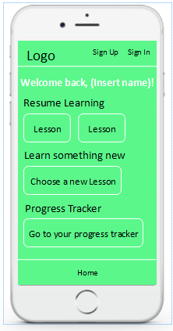

This is the page you would see, after you signed in to your account. It would show you what lessons you haven’t completed under the “Resume Learning” section, it would allow you to learn a new concept if you click on the “Choose a new lesson” button, which would take you to the lessons page for the grade you had previously selected. The Progress Tracker link would take you to a separate page.

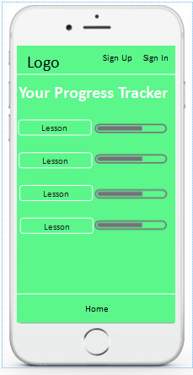

This is what the progress tracker button, from the previous page, would take you to. This tracks how you did on the quizzes, so for example, if you got a 50% on a quiz, the progress tracker would show that you are 50% done for that lesson. You can redo the quizzes as many times as you want, so that your progress tracker says that that lesson has been completed.

**Main Steps for Creating the Project**

1. Make a list of all the concepts for each grade, and learn them/figure out how to explain them.
2. Make the lessons and the quizzes.
3. Make the home page.
4. Make the page where it allows you to choose a grade, and then choose a concept,
5. Make the sign-in and sign-up pages.
6. Make the pages personalized with what the person has already done.
7. Make the progress tracker, and have it connected to the quizzes.
8. Have a way for them to log out of the website.

**What languages I will be using**

1. HTML
2. CSS
3. JavaScript

These are the languages I believe I will need to use when making my project. As I go along, I will see if I need to learn other programming languages, based on what I need to create for the project.

I’ll start my coding in Komodo Edit, but if I realize I need to use another program, that will be determined later on.